PRESENTING CLINICAL SIGNS
History: Possible FB, chronic GI issues.
Physical Examination: N/A.
Urinalysis: N/A.
CBC: N/A.
Serum Biochemistry: N/A.
Radiographic Findings: N/A.

ULTRASONOGRAPHIC EXAMINATION OF THE ABDOMEN
Urinary System
Full urinary bladder with a normal thickness and appearance of the wall. Normal anechoic urine with no sediment or uroliths evident.
Normal trigone area, proximal urethra (0.4 cm), and iliac blood vessels.
Normal iliac lymph nodes (1 cm). Ureters not visualized.
Normal renal size (left 3 cm, right 3.2 cm), echogenic appearance, cortico-medullary differentiation, pelvis, and capsule.
Reproductive System
Small hypoechogenic prostate (0.7 cm).
Adrenal Glands
Normal shape, echogenic appearance, and position. Normal size of left (0.39/0.34 cm); small and flattened right gland (0.28/0.27 cm).
Spleen
Normal size (0.7 cm) and echogenic appearance. Smooth homogenous parenchyma, smooth curvi-linear capsule, and normal vasculature. No evidence of inflammatory, neoplastic, infarction, or infiltrative changes noted.
Liver
Normal size, echogenic appearance, and portal markings. No nodules or masses evident. Full gall bladder containing normal anechoic bile. Normal thickness and appearance of the gall bladder wall. Normal bile duct (0.2 cm).
Gastrointestinal
Normal appearance of the stomach, duodenum, small intestine, ileo-cecal junction, and colon with no loss of layering, normal wall thickness (duodenum 0.27 cm, jejunum 0.26 cm) and peristaltic activity and no distension of the lumen. Ingesta within the stomach.
Pancreas
Normal size (right 1 cm) with a mottled echogenic and irregular appearance. Hyperechogenic appearance of the mesentery and fat surrounding the pancreas.
Free Abdomen
Normal mesenteric lymph nodes (2.1 cm).
No ascites.

ULTRASONOGRAPHIC FINDINGS
Primary Findings:
- Pancreatitis.
- Small right adrenal gland.
Secondary Findings:
- None.

INTERPRETATION OF THE FINDINGS & FURTHER RECOMMENDATIONS
The appearance of the pancreas is consistent with pancreatitis with fibrosis, a differential diagnosis.

Although the small right adrenal gland may be an incidental finding, Addison’s disease needs to be considered.

Further assessment would be cPL/PSL assay and basal cortisol.

Specific therapy would be dependent on an etiological diagnosis.

IMAGES
Pancreas
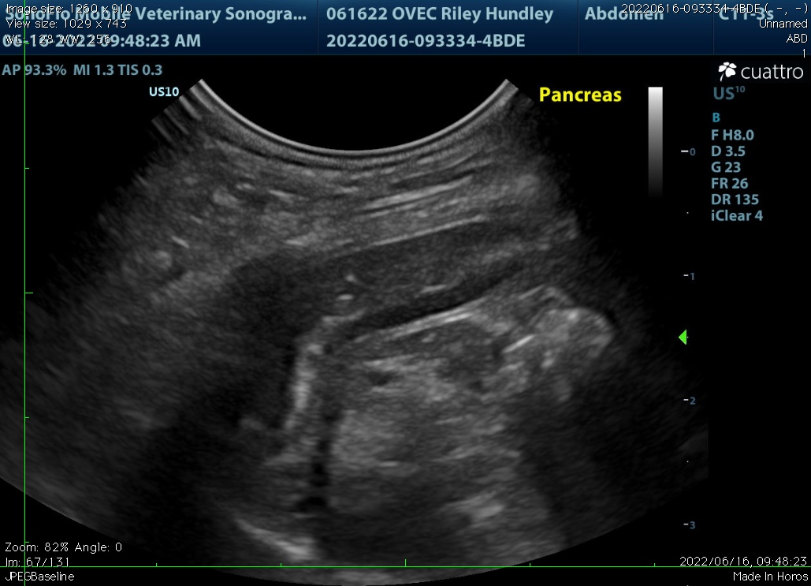

The information and recommendations provided are based on the images presented by the referring veterinarian. No evaluation can be communicated regarding pathology that was not visible in the image/video clips provided.

Thank you for this referral. If the clinical or image interpretation does not parallel your findings or if I can be of any further assistance, please contact me.

Remo Lobetti, BVSc, MMedVet (Med), PhD, Dipl. ECVIM (Internal Medicine)
rlobetti@mweb.co.za

